Looper Viewer

User Manual

Document Table of Contents
1 Background & Introduction 3
1.1 Background 3
1.2 Introduction 3
2 Software Overview 3
2.1 Main Interface 3
2.2 Menu Bar 4
2.2.1 File Functions 4
2.2.2 View Functions 4
2.2.2.1 Log Information Window 5
2.2.3 Tools Functions 5
2.2.3.1 Viewer Settings Interface 5
2.3 Image Preview Area 6
2.4 Contol and Processing Area 7
3 Download & Installation 8
3.1 Download 8
3.2 Installation 8
3.2.1 Windows 8
3.2.2 Linux 8

- Background & Introduction
  - Background
Looper Viewer is a simple graphical application developed by Looper based on the Looper Insight 9 camera. It is designed to help developers quickly use and test Looper UVC camera mode.

  - Introduction
Looper Viewer provides video stream preview, real‑time VIO data visualization, post‑processing filters, and some debugging functions for the Looper Insight 9 camera via the InsightSDK. This document will explore the various features of the Looper camera, provide detailed explanations and operational demonstrations, and help users efficiently master the powerful capabilities of the Looper camera.

Software Overview

Main Interface
The main interface of Looper Viewer is divided into three areas:
- **Area 1:** Menu bar
- **Area 2:** Image preview area
- **Area 3:** Control and processing area
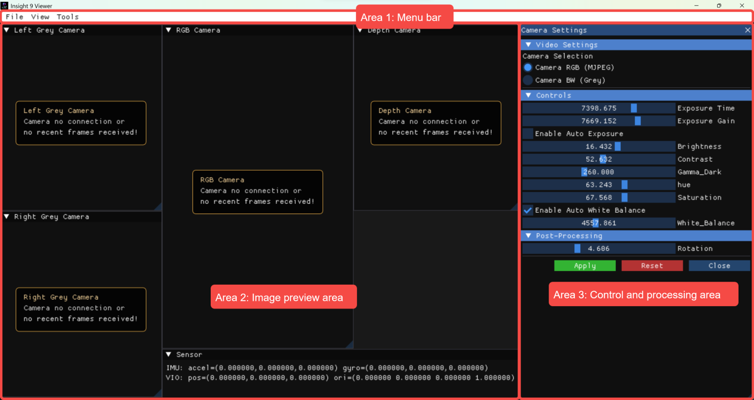
Figure 2-1 Main interface layout

**Table 2-1 Main interface functional descriptions**
Area | Name | Function Description
Area 1 | Menu bar | Provides shortcuts to “Common” functions
Area 2 | Image preview area | Data stream image preview, VIO information preview
Area 3 | Control/processing area | Image processing and control pages

Menu Bar
The menu bar is located at the top of the main interface. Buttons from left to right are: File, View, Tools.
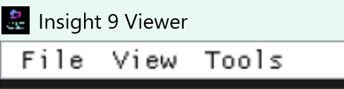
Figure 2-2 Menu bar

File Functions
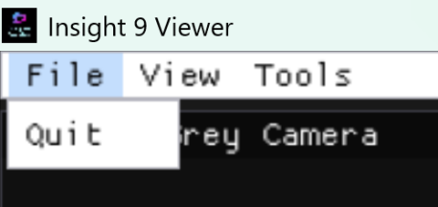
Currently only the Quit function is available – click to exit the application.
Figure 2-3 File functions

View Functions
Allows controlling the visibility of the image window, sensor window, log information area (in Area 2) and Area 3. Click the corresponding window option to toggle visibility.
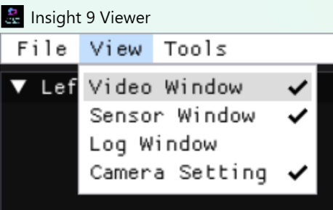
Figure 2-4 View functions

      - Log Information Window
Displays background log information for users to view runtime logs. There are **Copy** and **Clear** buttons in the upper‑left corner for debugging convenience.
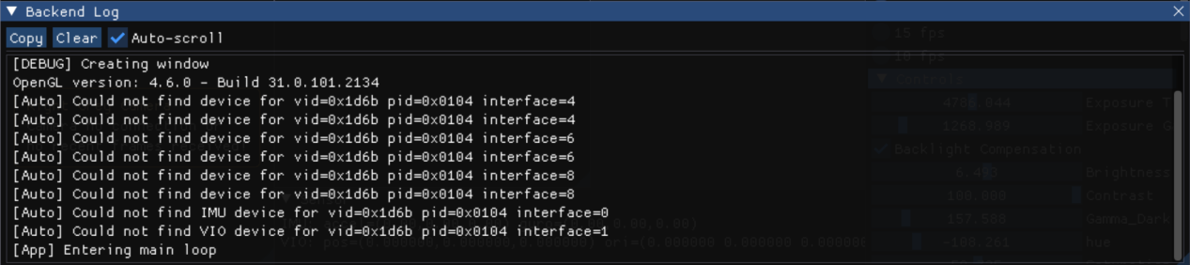
Figure 2-5 Log information area

Tools Functions
Currently only the function to open the Looper Viewer settings interface – click to pop up the Viewer settings.
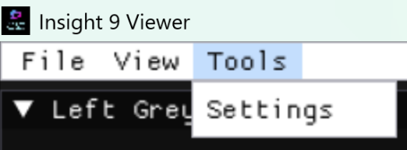
Figure 2-6 Tools functions

Viewer Settings Interface
The Viewer settings can be configured. Currently, the function of saving test logs is available. The real-time received data will be saved locally once per second.
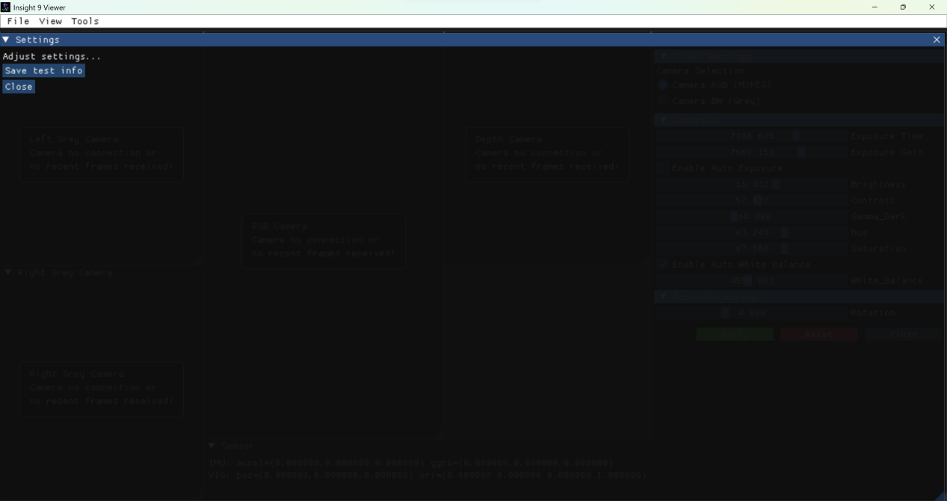
Figure 2-7 Viewer settings interface

Image Preview Area
The image preview area is located on the left side of the Looper Viewer main interface. It is the core display area, used to show the image data read by the program. By default, the window cannot be freely resized or dragged. If the **Lock window movement** option is disabled in the Viewer settings, the window becomes freely resizable and draggable, and the image will adapt to the window size.

When the Viewer cannot detect a Looper device, it will display a prompt such as “Camera no connection”. Once a Looper device is connected, it will automatically match and display the image in the corresponding window.
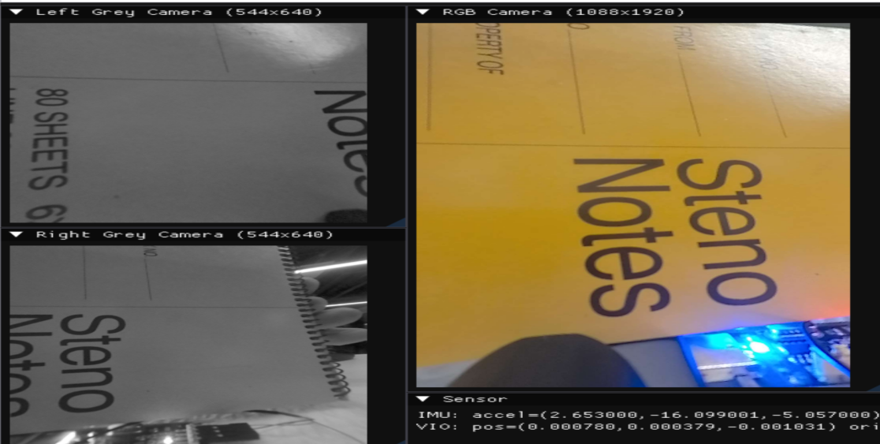
Figure 2-8 Image preview area

Contol and Processing Area
The control and processing area is located on the right side of the Looper Viewer main interface. It is the area for camera control. By clicking or dragging the corresponding configuration options and then clicking the **Apply** button below, the corresponding configuration is sent to the Looper device and the Looper camera configuration is modified. The processed image and VIO data are returned. Click the **Reset** button to restore the Looper default configuration. **Close** closes the Camera Setting window.
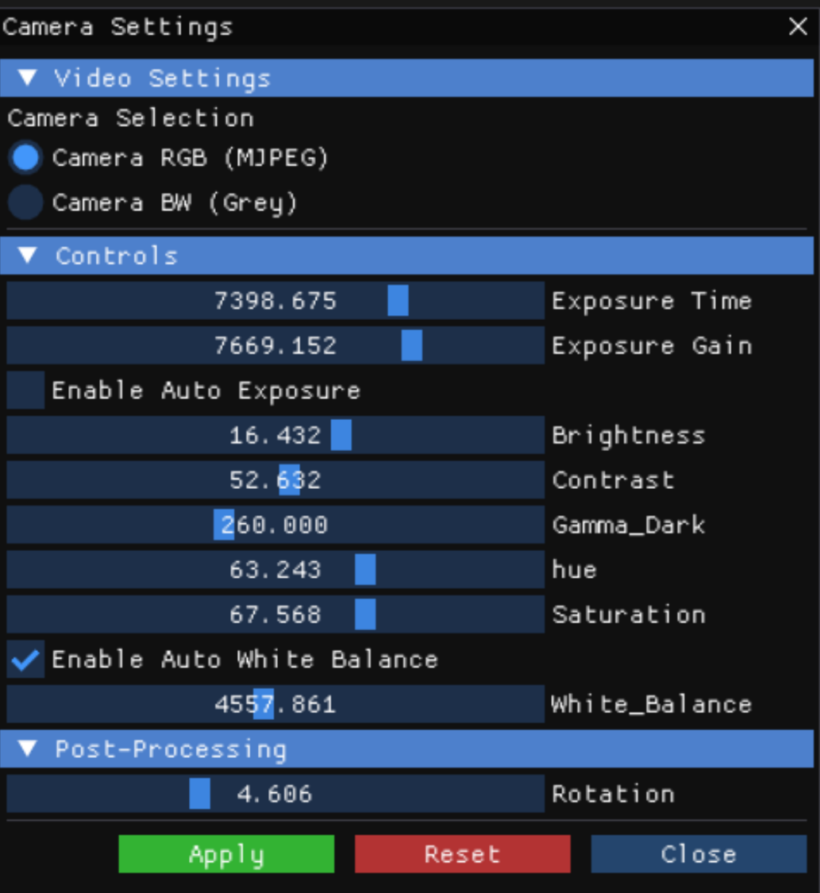
Figure 2-9 Control/processing area and function buttons

Download & Installation

Download
You can download Looper Viewer from the official Looper repository:
GitHub：https://github.com/LooperRobotics/insight-view
Official Looper SDK repository:
GitHub：
https://github.com/LooperRobotics/insight-sdk](https://github.com/LooperRobotics/insight-sdk

Installation

Windows
After downloading, simply extract the package to the desired directory – no additional installation is required. The folder contains the `Insight-Viewer.exe` executable and the default configuration file `configs/default.json`.
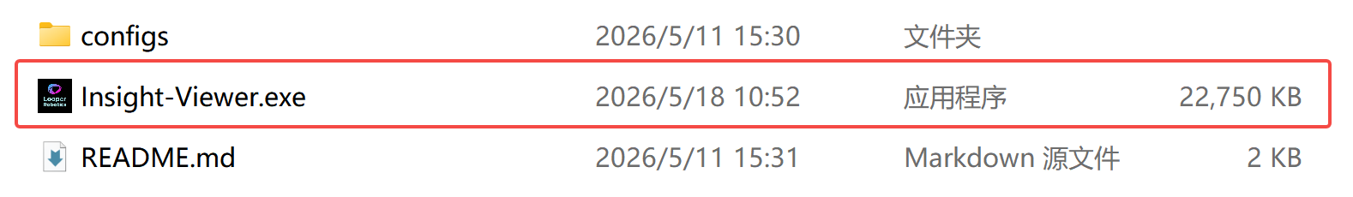

Figure 3-1 Windows

Linux
After downloading, the first time you run it, you need to execute the install_deps.sh script to automatically detect and download the required dependencies. After that, you can run the run.sh script with administrator privileges to automatically open the program, or you can manually execute the Insight_Viewer program in the bin folder.

Figure 3-2 On the Linux side, executed through script
Figure 3-3 On the Linux side, simply run it directly

